

BRAINWARE UNIVERSITY
School of Engineering
Department of Computer Science&Engineering–Cyber Security & Data Science
398, Ramkrishnapur Road, Barasat, North 24 Parganas, Kolkata – 700 125

Basic AI Tools & Applications (6BWUVAC001)

B.TECH PROJECT REPORT

Project Title:
AI-Powered Smart Study Planner

Created By:
Name: PRIYO CHAND
Student code: BWU/BTD/23/314
Course Code: 6BWUVAC001
Course Name: Basic AI Tools & Applications
Section: A
Semester: 6th
Year: 3rd
Department: CSE-CS & DS
Programme: B.TECH CSE(DATA SCIENCE)

Certificate

This is to certify that the project entitled " AI-Powered Smart Study Planner " has been carried out by Priyo Chand , under the guidance of the faculty of the Department of Computer Science and Engineering (Cyber Security & Data Science), Brainware University, in partial fulfilment of the requirements for the course Basic AI Tools & Applications (6BWUVAC001).

The work presented in this report is original and has not been submitted elsewhere for the award of any degree or diploma.

Project Guide Head of Department

Signature & Name of Guide Signature & Name of HOD

Declaration

I hereby declare that the project work entitled " AI-Powered Smart Study Planner " submitted to Brainware University, in partial fulfilment of the requirements for the course Basic AI Tools & Applications (6BWUVAC001), is a record of original work done by me under the supervision and guidance of the faculty of the Department of Computer Science and Engineering (Cyber Security & Data Science).

The content of this project has not been submitted in any other institution/university for the award of any degree or diploma. All the information presented in this project is true and original to the best of my/our knowledge.

Student Signature & Name Date

Acknowledgement

I express my sincere gratitude to Brainware University and the Department of Computer Science and Engineering (Cyber Security & Data Science) for providing the resources, infrastructure, and academic environment necessary to carry out this project.

I am deeply thankful to my project guide for their constant support, insightful guidance, and encouragement throughout the development of this project. Their expertise in Data Visualization and Machine Learning was invaluable in shaping the direction of this work.

I also extend my thanks to all faculty members of the department for their timely feedback and academic support during the course Basic AI Tools & Applications (6BWUVAC001).

Finally, I express gratitude to my family and peers for their constant motivation and moral support throughout this journey.

Abstract

This project presents an AI-Powered Smart Study Planner, designed to assist students in improving their academic performance through intelligent data analysis and personalized recommendations. Many students face challenges in managing their study time effectively and identifying their weak areas. This system addresses these challenges by collecting and analyzing study-related data such as study hours, sleep duration, attendance percentage, assignment completion, and previous academic performance.

The application is developed using Python and Streamlit, providing a user-friendly and interactive web-based interface. A SQLite database is used to store user profiles and study logs securely. The core of the system is a machine learning model based on Random Forest Regression, which is trained on a dataset containing multiple academic parameters to predict student performance.

The system includes multiple modules such as user authentication, study log tracking, performance dashboard, AI-based study planner, and profile management. It also provides visual analytics such as graphs and charts to help users understand their performance trends over time.

The primary objective of this project is to help students identify weak subjects, improve consistency, and optimize their study strategies using AI-driven insights. The system aims to enhance productivity, decision-making, and overall academic outcomes.

Table of Contents

- Introduction
- Literature Review
- System Architecture
- Dataset Description
- Methodology with Code Snippets
- Results and Analysis
- GUI / Web Interface
- Discussion
- Conclusion
- Future Scope

Introduction

In the modern academic environment, students often face significant challenges in managing their time effectively and maintaining consistency in their studies. With increasing academic pressure, it becomes difficult for students to track their performance and identify areas where improvement is required. Traditional study methods and planners mainly focus on scheduling tasks but fail to provide insights into performance trends or personalized recommendations.
To address these challenges, this project proposes an AI-Powered Smart Study Planner, which utilizes data-driven techniques to assist students in optimizing their study habits. The system collects various parameters such as study hours, sleep duration, attendance percentage, assignment completion rate, and previous academic performance. Based on these inputs, the system analyzes patterns and predicts future performance.
The key objectives of this system are:
- To track daily study activities efficiently
- To predict academic performance using machine learning
- To provide personalized recommendations for improvement
- To visualize performance trends using interactive dashboards
The system integrates Machine Learning, Database Management Systems, and Web Technologies to create a complete and intelligent study assistant. By combining these technologies, the application not only helps students monitor their progress but also guides them towards achieving better academic outcomes.
Literature Review
Several study planning applications and tools are available today; however, most of them are limited to basic scheduling and task management functionalities. These traditional systems do not incorporate intelligent mechanisms to analyze user behavior or predict academic performance. As a result, they fail to provide meaningful insights or personalized study strategies.
Existing systems generally lack the following capabilities:
- Prediction of academic performance based on study patterns
- Analysis of multiple influencing factors such as sleep, consistency, and attendance
- Real-time feedback and adaptive study planning
- Data visualization for better understanding of progress
Recent advancements in Artificial Intelligence and Machine Learning have enabled the development of intelligent systems that can analyze large datasets and extract useful patterns. Educational data mining and learning analytics have shown promising results in improving student performance through predictive analysis.
This project enhances traditional study planners by incorporating:
- Machine Learning models for performance prediction
- Data analytics dashboards for visual insights
- Personalized study recommendations based on user data
- Interactive web interface for ease of use
Thus, the proposed system bridges the gap between traditional planners and intelligent learning systems by providing a more effective and data-driven approach to academic improvement.

System Architecture
The system architecture of the AI-Powered Smart Study Planner is designed to integrate user interaction, backend processing, database storage, and machine learning prediction into a unified system.
The architecture follows a modular approach consisting of the following components:

1. User Interface (Frontend)
The frontend is developed using Streamlit, which allows users to:
- Log in and register
- Enter study data
- View dashboard analytics
- Access personalized study plans

2. Backend Processing
The backend is implemented using Python and handles:
- Data validation
- Business logic
- Interaction with database
- Communication with machine learning model

3. Database (SQLite)
The system uses SQLite database to store:
- User credentials
- Study logs
- Performance history
Example code for database connection:
conn = sqlite3.connect(DB_PATH)

4. Machine Learning Model
A Random Forest Regression model is used to:
- Analyze input features
- Predict student performance
- Provide data-driven insights

5. Output Layer
The output is displayed in the form of:
- Dashboard graphs
- Performance metrics
- Study recommendations

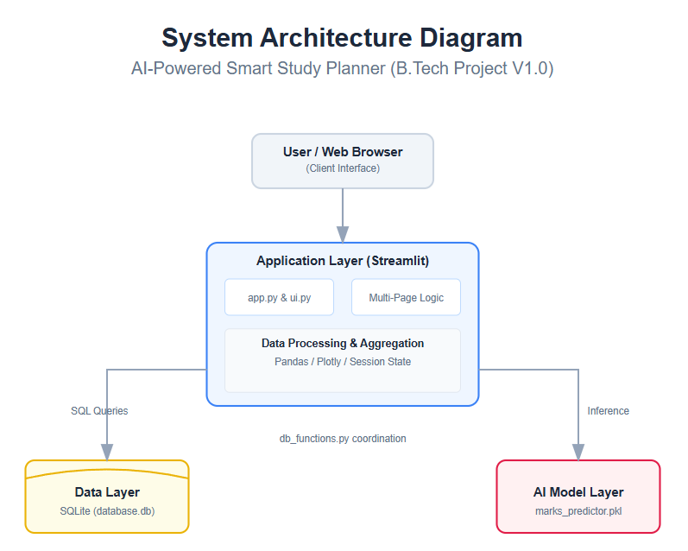

Dataset Description
The dataset used in this project is synthetically generated to simulate realistic student behavior and academic performance patterns. It is created using Python and stored in CSV format.

Dataset Features
The dataset contains the following attributes:
- Study_Hours – Number of hours studied per day
- Sleep_Hours – Daily sleep duration
- Attendance_Pct – Attendance percentage
- Assignments_Completed – Percentage of assignments completed
- Daily_Consistency – Number of study days per week
- Study_Days_Remaining – Days left before exam
- Previous_Marks – Marks obtained in previous exams

Target Variable
- Final_Marks – Predicted academic performance

Dataset Generation Logic
The dataset is generated using random values with realistic constraints:
study_hours = np.round(np.random.uniform(1.0, 8.0), 1)
previous_marks = np.round(np.random.uniform(40.0, 95.0), 1)

Dataset Size
- Total Records: 500 students
- Multiple subjects included
- Balanced distribution of performance levels

Purpose of Dataset
The dataset is used to:
- Train the machine learning model
- Evaluate prediction accuracy
- Simulate real-world academic scenarios

Sample Dataset
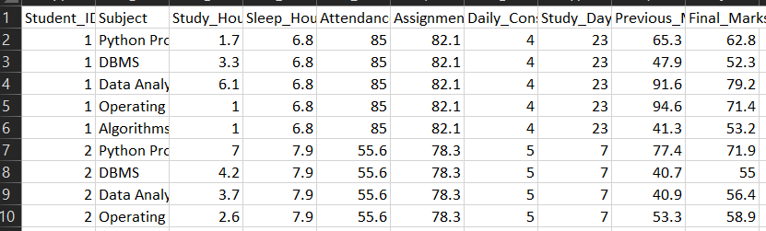
Methodology with Code Snippets

The methodology of this project involves multiple stages including data generation, model training, prediction, and user interaction through the web interface.

3.1 Data Collection and Generation
The dataset used for training the model is synthetically generated using Python. It includes various academic parameters such as study hours, sleep hours, attendance, assignments, and previous marks.
import pandas as pd
import numpy as np
import os

os.makedirs('data', exist_ok=True)
np.random.seed(42)

num_students = 500
subjects = ['Python Programming', 'DBMS', 'Data Analytics', 'Operating Systems', 'Algorithms']
data = []

print("Generating perfectly aligned student data...")

for student_id in range(1, num_students + 1):
# Student baselines
base_attendance = np.clip(np.random.normal(80, 10), 40, 100)
base_sleep = np.clip(np.random.normal(7, 1.5), 4, 10)
consistency = np.random.randint(2, 8)

# NEW: Added Assignments Completed (Percentage)
assignments_completed = np.clip(np.random.normal(75, 15), 0, 100)

# NEW: Added Study Days Remaining before exam
days_remaining = np.random.randint(5, 45)

for subject in subjects:
study_hours = np.round(np.random.uniform(1.0, 8.0), 1)
previous_marks = np.round(np.random.uniform(40.0, 95.0), 1)

# Updated Logic: Including Assignments and Days Remaining
# If they have few days remaining but high study hours, they cram well.
# High assignments completed boosts marks.
calculated_marks = (
(study_hours * 3.0) +
(previous_marks * 0.35) +
(base_attendance * 0.10) +
(assignments_completed * 0.15) + # New weight
(consistency * 1.5) +
((base_sleep - 6) * 1.5) +
np.random.normal(0, 5)
)

# Minor penalty if exam is close (days_remaining < 10) and consistency is low
if days_remaining < 10 and consistency < 4:
calculated_marks -= 5

final_marks = np.clip(calculated_marks, 0, 100)

data.append([
student_id, subject, study_hours, np.round(base_sleep, 1),
np.round(base_attendance, 1), np.round(assignments_completed, 1),
consistency, days_remaining, previous_marks, np.round(final_marks, 1)
])

df = pd.DataFrame(data, columns=[
'Student_ID', 'Subject', 'Study_Hours', 'Sleep_Hours',
'Attendance_Pct', 'Assignments_Completed', 'Daily_Consistency',
'Study_Days_Remaining', 'Previous_Marks', 'Final_Marks'
])

df.to_csv('data/final_student_data.csv', index=False)
print(f"✅ Generated data with ALL requested features for {num_students} students!")

3.2 Machine Learning Model Training
A Random Forest Regressor is used to train the model. The dataset is divided into training and testing sets, and a pipeline is created for preprocessing and prediction.
import pandas as pd
import numpy as np
from sklearn.model_selection import train_test_split
from sklearn.ensemble import RandomForestRegressor
from sklearn.preprocessing import OneHotEncoder
from sklearn.compose import ColumnTransformer
from sklearn.pipeline import Pipeline
from sklearn.metrics import mean_absolute_error, r2_score
import pickle
import os
print("Loading dataset...")
# Load the data we just generated
df = pd.read_csv('data/final_student_data.csv')
# Define features (X) and target (y)
X = df[['Subject', 'Study_Hours', 'Sleep_Hours', 'Attendance_Pct', 'Assignments_Completed', 'Daily_Consistency', 'Study_Days_Remaining', 'Previous_Marks']]
y = df['Final_Marks']
# Split into training and testing sets (80% train, 20% test)
X_train, X_test, y_train, y_test = train_test_split(X, y, test_size=0.2, random_state=42)
print("Building AI Model Pipeline...")
# We use OneHotEncoder to turn the text 'Subject' into numbers the AI can understand
preprocessor = ColumnTransformer(
transformers=[
('cat', OneHotEncoder(handle_unknown='ignore'), ['Subject'])
], remainder='passthrough'
)
# Create a pipeline that preprocesses the data, then runs the Random Forest model
model_pipeline = Pipeline(steps=[
('preprocessor', preprocessor),
('regressor', RandomForestRegressor(n_estimators=100, random_state=42))
])
print("Training the AI (This might take a few seconds)...")
model_pipeline.fit(X_train, y_train)
# Test the model's accuracy
predictions = model_pipeline.predict(X_test)
mae = mean_absolute_error(y_test, predictions)
r2 = r2_score(y_test, predictions)
print(f"🎯 Model Accuracy Details:")
print(f"Mean Absolute Error: {mae:.2f} marks (Predictions are usually within this many marks)")
print(f"R-Squared Score: {r2:.2f} (1.0 is perfect)")
# Save the trained model to be used by the Streamlit app
os.makedirs('model', exist_ok=True)
with open('model/marks_predictor.pkl', 'wb') as file:
pickle.dump(model_pipeline, file)

print("✅ AI Model saved successfully to 'model/marks_predictor.pkl'!")The trained model is saved using pickle for later use in the application.
with open('model/marks_predictor.pkl', 'wb') as file:
pickle.dump(model_pipeline, file)

3.3 Prediction System
The trained model is used to predict student performance based on user input.
predicted_mark = round(model.predict(input_data)[0], 1)
The system also applies constraints to ensure realistic predictions.

3.4 Database Integration
The application uses SQLite database to store user data and study logs.
import sqlite3
import pandas as pd
from datetime import date
import os

os.makedirs('data', exist_ok=True)
DB_PATH = 'data/database.db'

def init_db():
conn = sqlite3.connect(DB_PATH)
c = conn.cursor()

# 1. Study Logs Table
c.execute('''
CREATE TABLE IF NOT EXISTS study_logs (
id INTEGER PRIMARY KEY AUTOINCREMENT,
username TEXT, log_date TEXT, subject TEXT, study_hours REAL,
sleep_hours REAL, attendance REAL, assignments REAL, consistency INTEGER,
days_remaining INTEGER, previous_marks REAL, predicted_marks REAL
)
''')

# --- UPGRADE: Add new qualitative columns to study_logs dynamically ---
new_log_columns = {
'focus_score': 'INTEGER',
'session_notes': 'TEXT'
}

for col_name, data_type in new_log_columns.items():
try:
c.execute(f'ALTER TABLE study_logs ADD COLUMN {col_name} {data_type}')
except sqlite3.OperationalError:
pass # Column already exists, move on

# 2. Users Table
c.execute('''
CREATE TABLE IF NOT EXISTS users (
username TEXT PRIMARY KEY,
password TEXT NOT NULL
)
''')

# 3. UPGRADE: Add new profile columns dynamically
new_columns = {
'recovery_word': 'TEXT',
'full_name': 'TEXT',
'institution': 'TEXT',
'degree_major': 'TEXT',
'current_semester': 'TEXT',
'target_cgpa': 'REAL'
}

for col_name, data_type in new_columns.items():
try:
c.execute(f'ALTER TABLE users ADD COLUMN {col_name} {data_type}')
except sqlite3.OperationalError:
pass # Column already exists, move on

conn.commit()
conn.close()

# --- AUTHENTICATION & PROFILE FUNCTIONS ---
def register_user(username, password, recovery_word):
conn = sqlite3.connect(DB_PATH)
c = conn.cursor()
try:
c.execute('INSERT INTO users (username, password, recovery_word) VALUES (?, ?, ?)', (username, password, recovery_word))
conn.commit()
success = True
except sqlite3.IntegrityError:
success = False
conn.close()
return success

def verify_user(username, password):
conn = sqlite3.connect(DB_PATH)
c = conn.cursor()
c.execute('SELECT * FROM users WHERE username=? AND password=?', (username, password))
result = c.fetchone()
conn.close()
return result is not None

def verify_recovery_word(username, recovery_word):
conn = sqlite3.connect(DB_PATH)
c = conn.cursor()
c.execute('SELECT * FROM users WHERE username=? AND LOWER(recovery_word)=LOWER(?)', (username, recovery_word))
result = c.fetchone()
conn.close()
return result is not None

def reset_password(username, new_password):
conn = sqlite3.connect(DB_PATH)
c = conn.cursor()
c.execute('UPDATE users SET password=? WHERE username=?', (new_password, username))
conn.commit()
conn.close()

# --- GET AND UPDATE PROFILE DATA ---
def get_user_profile(username):
"""Fetches all profile data for a specific user."""
conn = sqlite3.connect(DB_PATH)
c = conn.cursor()
c.execute('SELECT full_name, institution, degree_major, current_semester, target_cgpa FROM users WHERE username=?', (username,))
result = c.fetchone()
conn.close()
return result

def update_user_profile(username, full_name, institution, degree_major, current_semester, target_cgpa):
"""Saves the user's academic profile to the database."""
conn = sqlite3.connect(DB_PATH)
c = conn.cursor()
c.execute('''
UPDATE users
SET full_name=?, institution=?, degree_major=?, current_semester=?, target_cgpa=?
WHERE username=?
''', (full_name, institution, degree_major, current_semester, target_cgpa, username))
conn.commit()
conn.close()

# --- STUDY LOG FUNCTIONS ---
def save_study_log(username, log_date, subject, study_hours, sleep_hours, attendance, assignments, consistency, days_remaining, prev_marks, predicted_marks, focus_score, session_notes):
conn = sqlite3.connect(DB_PATH)
c = conn.cursor()
# Updated to include focus_score and session_notes
c.execute('''
INSERT INTO study_logs
(username, log_date, subject, study_hours, sleep_hours, attendance, assignments, consistency, days_remaining, previous_marks, predicted_marks, focus_score, session_notes)
VALUES (?, ?, ?, ?, ?, ?, ?, ?, ?, ?, ?, ?, ?)
''', (username, str(log_date), subject, study_hours, sleep_hours, attendance, assignments, consistency, days_remaining, prev_marks, predicted_marks, focus_score, session_notes))
conn.commit()
conn.close()

def get_user_history(username):
conn = sqlite3.connect(DB_PATH)
df = pd.read_sql_query("SELECT * FROM study_logs WHERE username=?", conn, params=(username,))
conn.close()
return df

3.5 Web Application Interface
The frontend is built using Streamlit, which provides an interactive interface for users.
import streamlit as st
from utils.db_functions import init_db, verify_user, register_user, verify_recovery_word, reset_password

# 1. Page Configuration
st.set_page_config(page_title="AI Study Planner", page_icon="📚", layout="centered")

# --- CSS TO HIDE SIDEBAR ON LOGIN ---
hide_sidebar_style = """
<style>
[data-testid="stSidebarNav"] {display: none;}
footer {visibility: hidden;}
</style>
"""

init_db()

# Initialize Session States
if "logged_in" not in st.session_state:
st.session_state["logged_in"] = False
if "username" not in st.session_state:
st.session_state["username"] = ""

def login():
# Inject the CSS to hide the sidebar and default footer
st.markdown(hide_sidebar_style, unsafe_allow_html=True)

# --- BRANDING SECTION ---
col1, col2 = st.columns([1, 4])
with col1:
# Make sure you have your logo in the assets folder!
try:
st.image("assets/logo.jpg", width=100)
except:
st.image("https://illustrations.popsy.co/gray/student-with-books.svg", width=120)

with col2:
st.title("AI Smart Study Planner")
st.markdown("*Your personalized roadmap to academic excellence.*")

tab1, tab2, tab3 = st.tabs(["🔑 Login", "📝 Sign Up", "🆘 Forgot Password"])

with tab1:
with st.form("login_form"):
username = st.text_input("Username").strip()
password = st.text_input("Password", type="password")
submit = st.form_submit_button("Login", type="primary", use_container_width=True)

if submit:
if verify_user(username, password):
st.session_state["logged_in"] = True
st.session_state["username"] = username
st.switch_page("pages/1_📊_Dashboard.py")
else:
st.error("Invalid Username or Password. Please try again.")

with tab2:
st.info("Join thousands of students optimizing their study habits.")
with st.form("register_form"):
new_username = st.text_input("Choose a Username").strip()
new_password = st.text_input("Choose a Password", type="password")
recovery_word = st.text_input("Secret Recovery Word (e.g., Mother's Maiden Name)").strip()

if st.form_submit_button("Create Account", use_container_width=True):
if new_username and new_password and recovery_word:
if register_user(new_username, new_password, recovery_word):
st.success("✅ Account created! You can now log in.")
else:
st.error("⚠️ Username already exists.")
else:
st.warning("Please fill in all fields.")

with tab3:
st.info("Answer your security question to reset your password.")
with st.form("forgot_password_form"):
recover_user = st.text_input("Username").strip()
recover_word = st.text_input("Secret Recovery Word").strip()
new_pass = st.text_input("Enter NEW Password", type="password")

if st.form_submit_button("Reset Password", use_container_width=True):
if recover_user and recover_word and new_pass:
if verify_recovery_word(recover_user, recover_word):
reset_password(recover_user, new_pass)
st.success("✅ Password reset! Please use the Login tab.")
else:
st.error("❌ Credentials incorrect.")
else:
st.warning("Please fill in all fields.")

st.markdown("---")
st.caption("© 2026 AI Smart Study Planner | Optimized for Academic Success")

def landing_page():
st.title("🚀 You are logged in!")
st.write(f"Welcome back, **{st.session_state['username']}**.")

col1, col2 = st.columns(2)
with col1:
if st.button("📊 Go to My Dashboard", type="primary", use_container_width=True):
st.switch_page("pages/1_📊_Dashboard.py")
with col2:
if st.button("🚪 Logout", use_container_width=True):
st.session_state["logged_in"] = False
st.session_state["username"] = ""
st.rerun()

# --- MAIN LOGIC ---
if not st.session_state["logged_in"]:
login()
else:
landing_page()

Result and Analysis

The system successfully demonstrates the ability to analyze student study patterns and predict academic performance. The dashboard provides a comprehensive view of user activity, including total study hours, predicted marks, and focus levels.
Key observations from the system include:
- Students with higher consistency and study hours tend to have better predicted performance
- Sleep and focus also play an important role in determining outcomes
- The system effectively identifies weak subjects and suggests improvements
The dashboard visualizes performance trends using graphs and charts, helping users understand their progress over time.
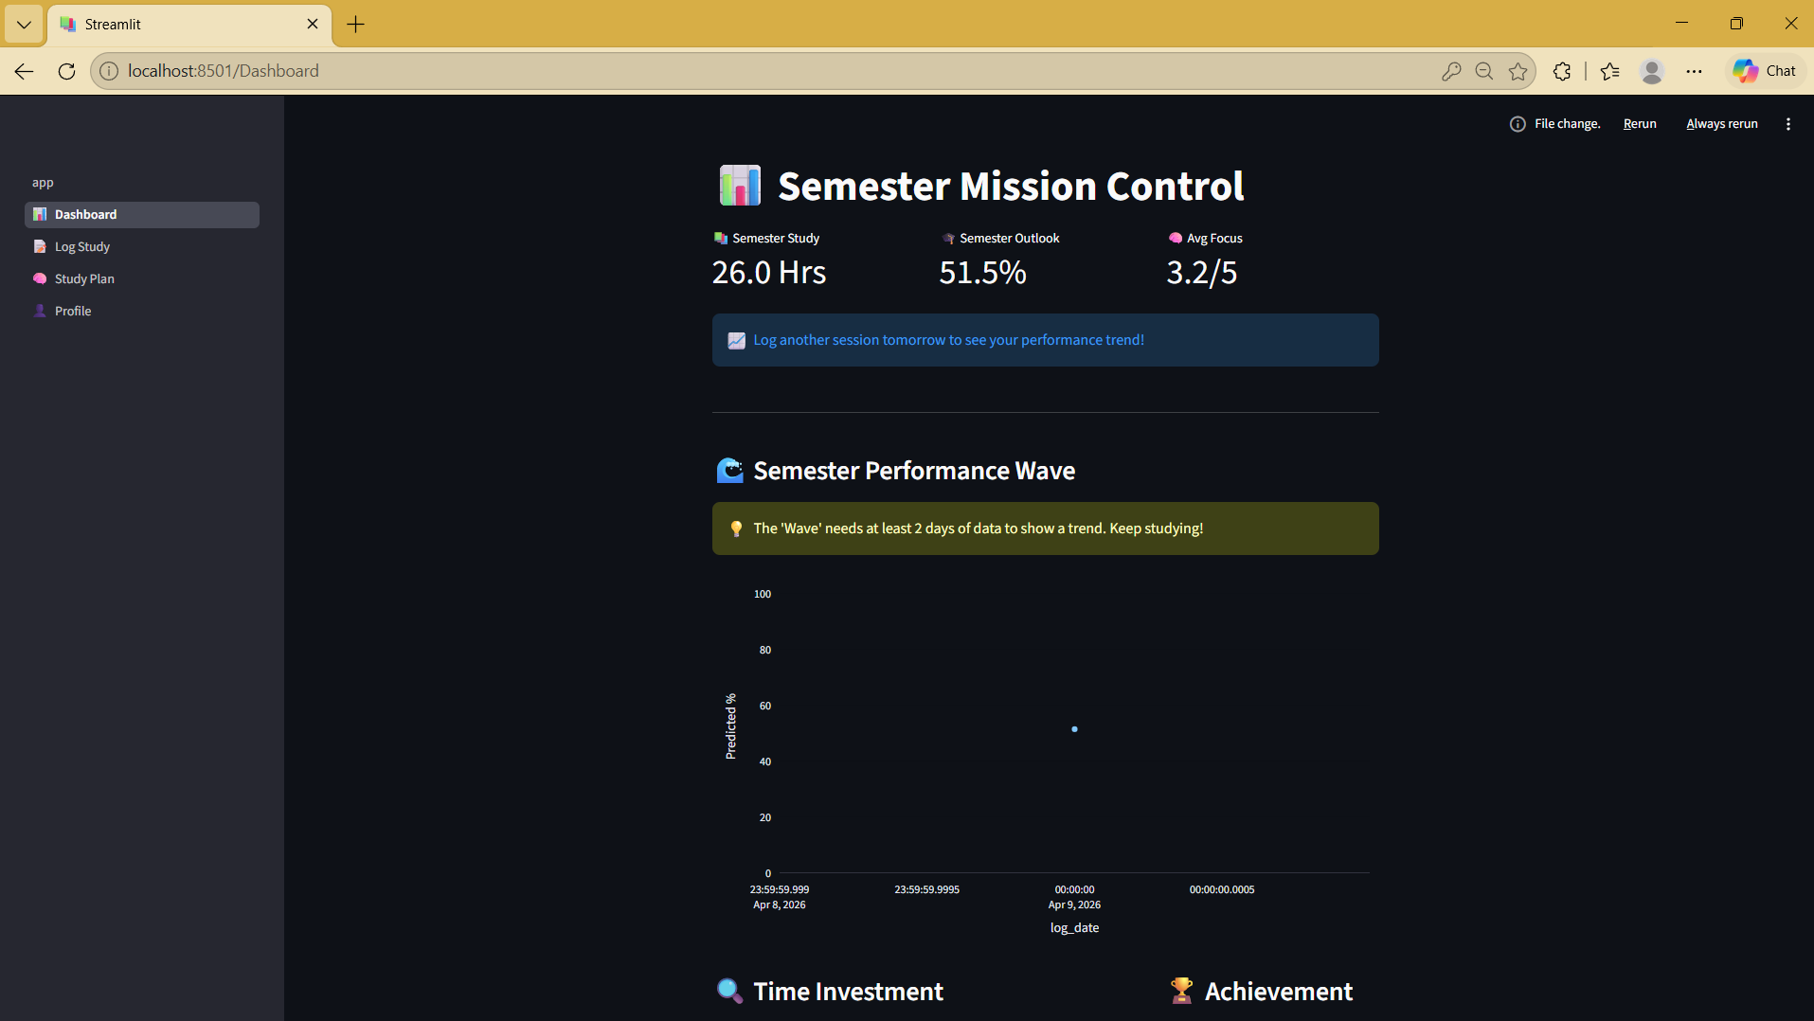
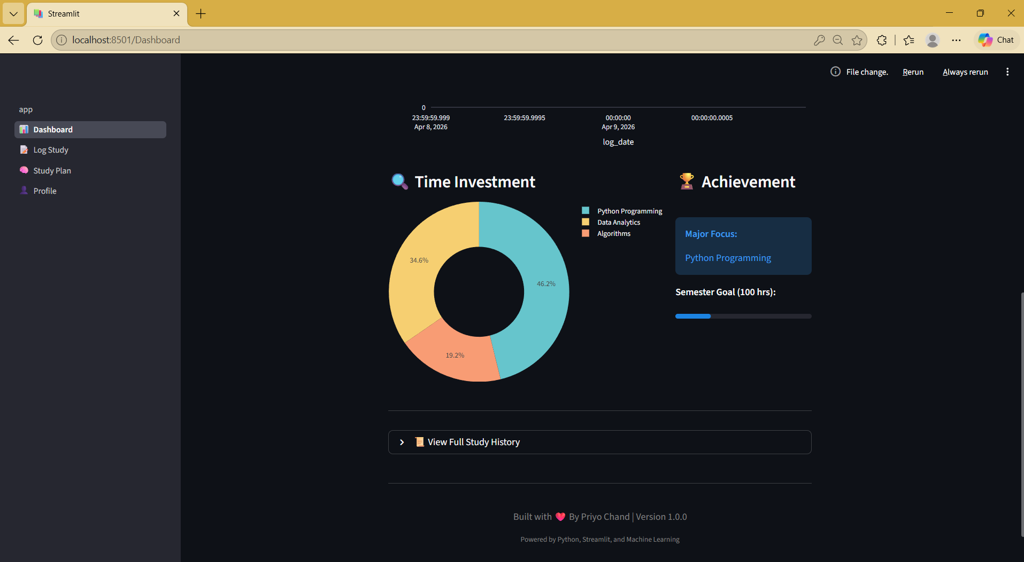

GUI / Web Interface

The application provides a user-friendly interface with multiple modules:
- Login & Signup Page – Secure user authentication
- Dashboard – Displays analytics and performance metrics
- Study Log Page – Allows users to input daily study data
- Study Planner – Provides AI-based recommendations
- Profile Page – Manages user information
The interface is designed using Streamlit, ensuring simplicity and ease of use.

Login & Signup Page

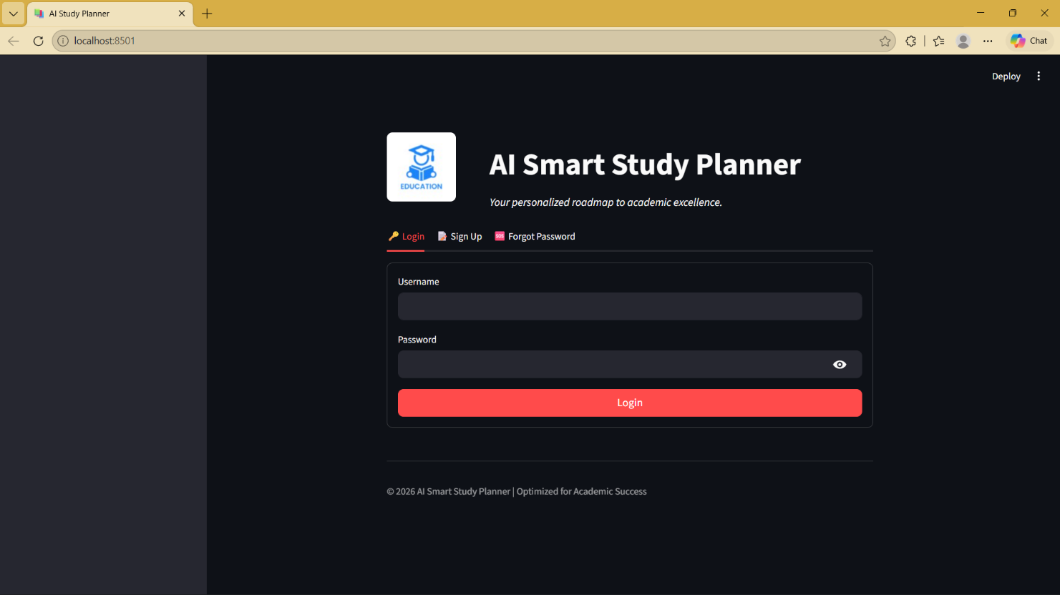

Dashboard Page



Study Log Page
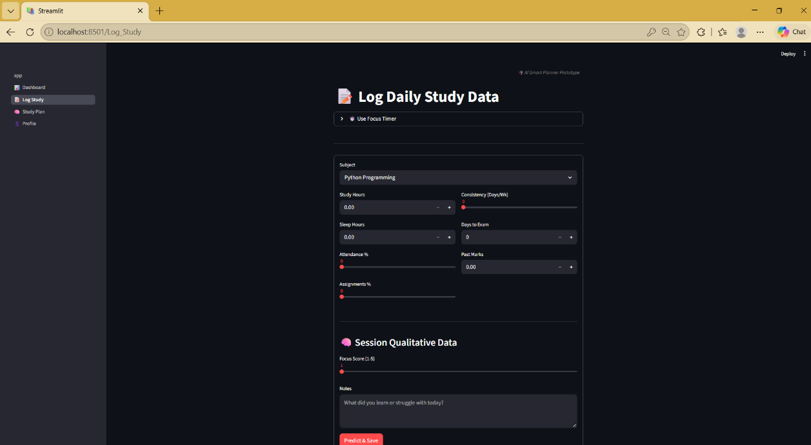
Study Planner
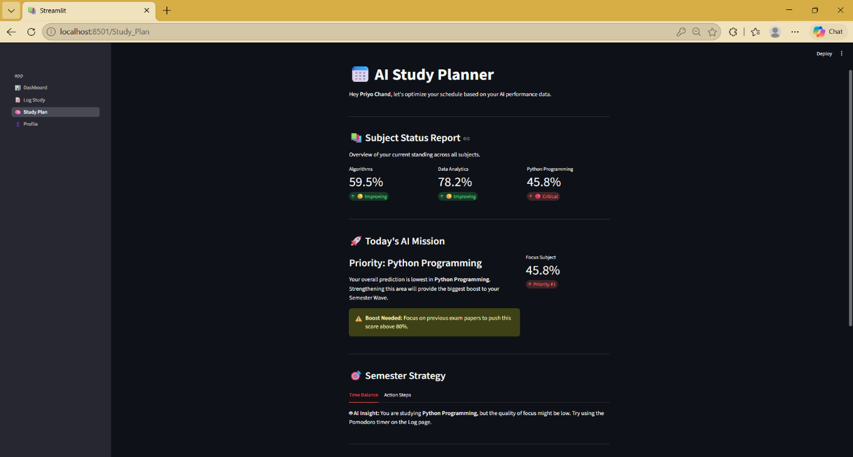

Profile Page
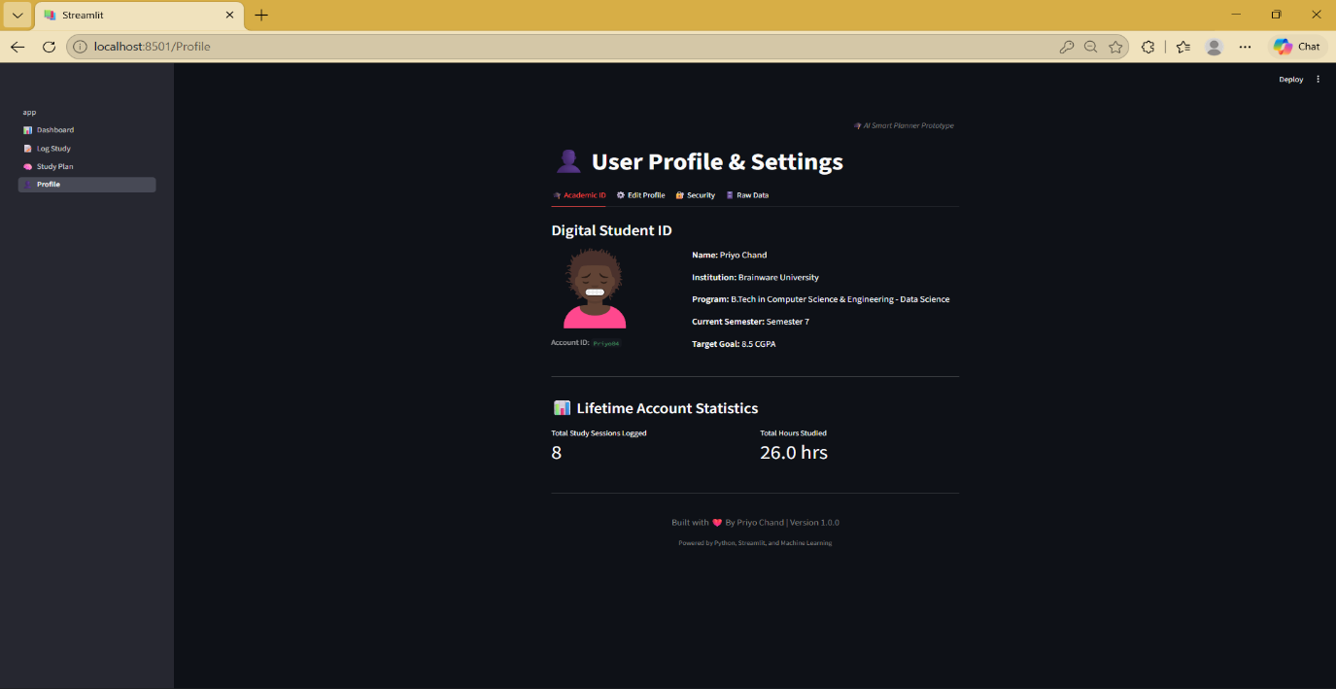
Discussion
The AI-Powered Smart Study Planner demonstrates how data-driven techniques can significantly improve student learning efficiency. The system successfully integrates user input, database storage, and machine learning to provide meaningful insights into academic performance.
One of the key strengths of the system is its ability to analyze multiple factors simultaneously, such as study hours, sleep duration, attendance, assignment completion, and consistency. Unlike traditional study planners, this system does not rely solely on scheduling but instead focuses on predictive analysis, which helps students understand the impact of their habits on academic outcomes.
The dashboard plays an important role in visualizing performance trends. By presenting data in the form of graphs and metrics, users can easily identify patterns such as improvement, decline, or stability in performance. This helps students take corrective actions in a timely manner.
Another significant feature is the AI-based study planner, which identifies weak subjects and suggests targeted improvements. This personalized recommendation system enhances decision-making and allows students to focus on areas that need the most attention.
However, the system has certain limitations. The dataset used for training is synthetically generated, which may not fully represent real-world scenarios. Additionally, the prediction accuracy depends on the quality of user input, meaning incorrect or inconsistent data may affect results.
Overall, the system demonstrates the practical application of machine learning in education and highlights the importance of combining technology with learning strategies to improve academic performance.

Conclusion
In conclusion, the AI-Powered Smart Study Planner successfully achieves its objective of assisting students in managing their studies more effectively through intelligent analysis and prediction. The system integrates multiple technologies, including Python, Streamlit, SQLite, and Machine Learning, to create a comprehensive and user-friendly solution.
The project demonstrates how machine learning can be used to predict student performance based on various academic parameters such as study hours, sleep patterns, attendance, and consistency. By analyzing these factors, the system provides valuable insights that help students make informed decisions about their study habits.
The interactive dashboard and visualization tools enhance the user experience by presenting complex data in a simple and understandable format. Additionally, the study planner module provides personalized recommendations, enabling students to focus on weak areas and improve their overall performance.
This project also highlights the importance of data-driven decision-making in education. By using predictive analytics, students can proactively adjust their study strategies instead of reacting to poor results after exams.
Overall, the system serves as an effective tool for improving productivity, maintaining consistency, and achieving better academic outcomes. It lays a strong foundation for future advancements in AI-based educational systems.

Future Scope
The current system provides a strong foundation for an intelligent study planning application; however, there are several opportunities for further enhancement and expansion.
One of the major improvements would be the use of real-world datasets instead of synthetically generated data. This would increase the accuracy and reliability of predictions and make the system more applicable in real academic environments.
The application can also be extended into a mobile application using frameworks such as Flutter or React Native, allowing students to access the system anytime and anywhere. This would improve usability and engagement.
Another potential enhancement is the integration of advanced machine learning or deep learning models, which can provide more accurate predictions and adaptive learning capabilities. Techniques such as neural networks or reinforcement learning could be explored.
The system can also incorporate real-time feedback mechanisms, such as notifications and reminders, to encourage consistency and discipline among students. Integration with calendar systems and scheduling tools can further improve time management.
Additionally, features like voice-based interaction using NLP, personalized learning paths, and integration with online learning platforms can significantly enhance the system’s functionality.
Finally, deploying the system on the cloud would allow scalability, multi-user access, and better performance, making it suitable for institutional use.

References

[1] C. Romero and S. Ventura, "Educational Data Mining: A Review of the State of the Art," IEEE Transactions on Systems, Man, and Cybernetics, Part C (Applications and Reviews), vol. 40, no. 6, pp. 601-618, Nov. 2010.
[2] J. L. Rastrollo-Guerrero, J. A. Gómez-Pulido, and A. Durán-Domínguez, "Analyzing and Predicting Students’ Performance by Means of Machine Learning: A Review," Applied Sciences, vol. 10, no. 3, p. 1042, 2020.
[3] G. Curcio, M. Ferrara, and L. De Gennaro, "Sleep loss, learning capacity and academic performance," Sleep Medicine Reviews, vol. 10, no. 5, pp. 323-337, Oct. 2006.
[4] K. Verbert, E. Duval, J. Klerkx, S. Govaerts, and J. L. Santos, "Learning Analytics Dashboard Applications," American Behavioral Scientist, vol. 57, no. 10, pp. 1500-1509, 2013.
[5] N. Dabbagh and A. Kitsantas, "Personal Learning Environments, social media, and self-regulated learning: A natural formula for connecting formal and informal learning," The Internet and Higher Education, vol. 15, no. 1, pp. 3-8, 2012.
[6] J. Hattie and G. M. Donoghue, "Learning strategies: A synthesis and conceptual model," npj Science of Learning, vol. 1, no. 1, pp. 1-13, 2016.
[7] F. Pedregosa et al., "Scikit-learn: Machine Learning in Python," Journal of Machine Learning Research, vol. 12, pp. 2825-2830, 2011. (Note: This cites the core machine learning library you used for the Linear Regression model).

